Waves and Tides

Name: ___________________________

GEOL1551

Objective:
The objective of this exercise was to familiarize with processes that control wave and tidal energy. Understanding this process is critical for making forecasts of conditions that occurred in the past, present or will occur in future.

Waves:
Understanding wave energy is of great significance due to its impacts on shipping, on coastal processes including sediment transport, erosion and biological systems, and for production of electricity.

Steps
Visited the URL: http://www.neracoos.org/

Went to the Buoy Map page. Located buoy B01 (red dot) – Hoverred over point to see its label.

Lat: 43.18 Lon: -70.42 *Remember where the buoy is located in relation to the shoreline of Maine*.

Questions

- Scroll down the page, and on the lower right side, select Graphing and Download. Working your way through this tool, create two graphs. The first graph should show wave height (meters) and wind speed together through time. The second graph should show wind direction through time for the Western Maine Shelf B01 site. Do this for hourly data over the time period of 12/1/2018 to 1/1/2019.

Save and upload your TWO graphs with this assignment.

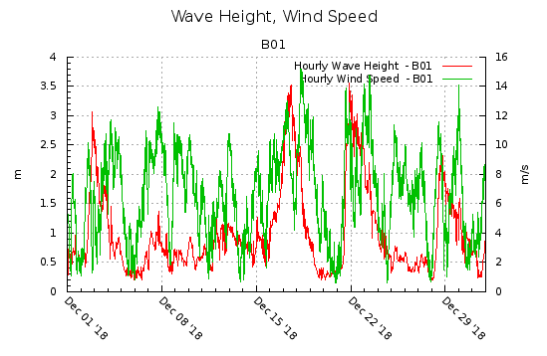

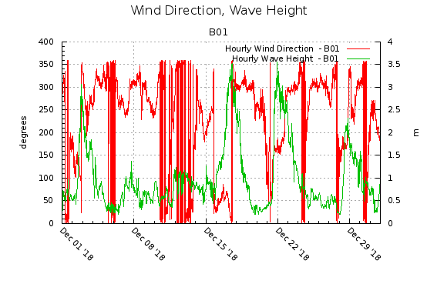
Using your graphs, answer the following questions.

- What is the dominant wind direction during this period of time (from which direction does the wind steadily blow most often)? Provide the answer in degrees (number 0-359) and cardinal direction (e.g., north, south, southeast, etc.). Note: the graph shows the direction from which the wind is blowing. 0 degrees means the wind is blowing FROM the north, 90 degrees means wind is blowing from the east, 180 from the south, and 270 from the west. Ignore days when the wind direction is extremely variable.

The dominant wind direction during this period is 360$°$ / 0$°$ hence wind was blowing from the North

- What is the relationship between wave height and wind speed? Are they always in sync? Provide specific examples (dates) of where they covary.

There is a high degree of correlation between the wind speed and the wave height but the two do not sync at all points. Wave height and wind speed covary in quite a number of instances like the period between Dec 22nd and Dec 29th, Dec 08th and Dec 15th. As stated, there is a correlation between wind speed and wave height, where there is high wind speed, the wave height is also high.

- What is the relationship between the peaks in wave height and wind direction?
When wave heights are high, the wind is blowing from the North and when wave heights are low, the wind is blowing from the East.

- Based on your answers above and observations from the map, what is controlling the wave height (and thus the wave energy) in this region. Keep in mind: it may be a combination of factors!

  - The speed of the wind, the higher the speed of the wind the higher the wave height.
  - The direction of the wind, when wave heights are high, the wind is blowing from the North and when wave heights are low, the wind is blowing from the East.
  - The phases of the moon, around the new and full moon phases, what is observed is a series of higher high tides and lower low tides perhaps due to the sun, moon and earth being aligned together, pulling the ocean’s water in same direction due to combined high gravitational force?
  - Wind duration. The longer the wind duration, the shorter the height of the waves.

Recall that deep water wave speed (c) is controlled by the wave period (T) using the equation: c = 1.56*T.

Because speed equals distance (wavelength: L) over time (c = L/T), the first equation can also be expressed as L = 1.56*T². Using this information and recalling that waves become unstable and break when height exceeds 1/7 the wavelength (H/L=1/7), calculate the maximum wave height that corresponds with the wave periods (T) shown below. Round to the nearest whole number.

- T=3s, Hmax = ____2___m

- T=7s, Hmax = ___10.92__m

- T=11s, Hmax = __26.97 m

- A typical wavelength of a tsunami may be 100 km. Given that, are tsunami deep-water waves, intermediate waves, or shallow-water waves?

Due to their long wavelengths, tsunami are shallow-water waves.

- How fast would a tsunami, with L=100 km, travel in 4.25 km of water (avg. depth of the oceans)? Give your answer in m/s. (Look in your book for the proper equation to use). SHOW YOUR WORK.

V = $\sqrt{g*d}$
g = 9.81 m/s²
d = the water depth
V = $\sqrt{9.81*4250}$ = 204.2 m/s
__204.2__ m/s

Tides

We’re going to look at predicted tide heights at two locations – One in NC, and one where I used to live in TX!

- Locate the following tidal stations and produce a one-month tidal record for August 2020 (Plot Daily) for each. How? Click the link, edit the dates at bottom left, and click “Plot Daily”. On each plot, label the sections corresponding to spring and Neap tides, save and upload with this assignment.

8651370 Duck, NC: https://tidesandcurrents.noaa.gov/noaatidepredictions.html?id=8651370

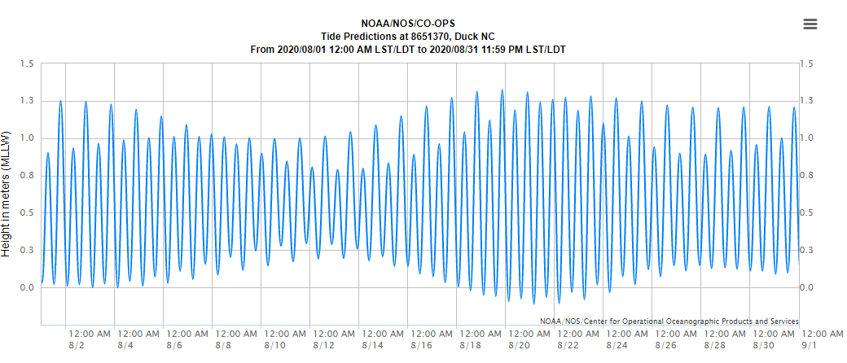
8771416 Galveston Bay Entrance, TX: https://tidesandcurrents.noaa.gov/noaatidepredictions.html?id=8771416

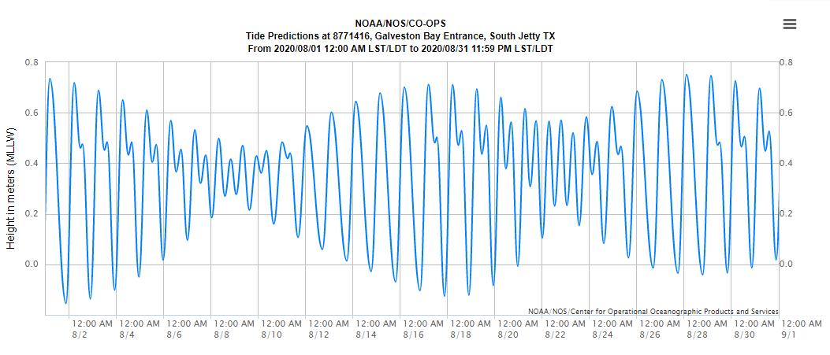

- What is the maximum range between high and low tide at each station? Which location has a greater tidal range?

8651370 Duck,
Highest tidal wave height = 1.32m
Lowest tidal wave height = -0.1m
Range = 1.32 – (-0.11) = 1.43m
8771416 Galveston Bay Entrance
Highest tidal wave height = 0.75m
Lowest tidal wave height = -0.15m
Range = 0.75 – (-0.15) = 0.9m

8651370 Duck, has a greater tidal range.

In the upper left of the website, click “Products” then scroll down to “Astronomical Data”. Look at a plot of the lunar phases during the same month as the tide data and use it to answer questions 15 & 16.

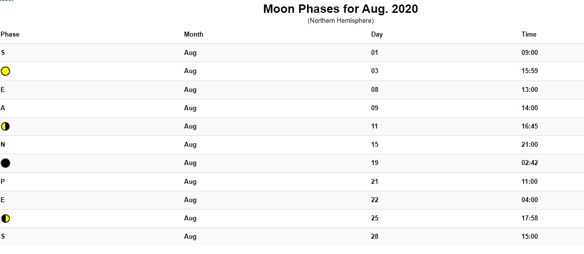

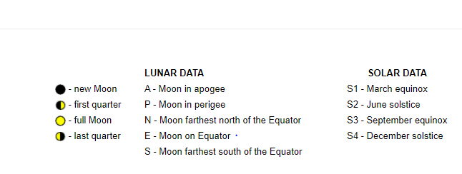

- Compare your tide charts to the phases of the moon for the month. How do the moon phases affect the tides?

Around the new and full moon phases, what is observed is a series of higher high tides and lower low tides perhaps due to the sun, moon and earth being aligned together, pulling the ocean’s water in same direction due to combined high gravitational force. Hence one can conclude that during the new and full moon phases there is occurrence of spring tides.

- Perigee and apogee configurations are also noted on the Astronomical Data chart. How do these configurations affect the tides?

Perigee occurs when the moon is at its closest to the earth and it is during this phase that tide generating forces are highest than the usual hence resulting in above average ranges in tidal waves. During apogee, the moon is at its farthest from the earth resulting in a smaller tide raising force hence tidal ranges become less than the average.

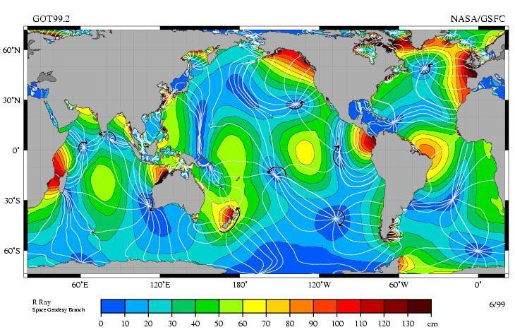

Map of the M2 (lunar semidiurnal) tides with cotidal and corange lines.

Answer the questions below using the tide map above

17. How many amphidromic points can you count? 15 amphidromic points

- What tidal range corresponds with the position of amphidromic points? Zero
- What color corresponds to the highest tidal ranges? Dark red

- On which coasts do we find tidal ranges between 30 and 60cm? Be specific e.g., the east coast of Australia, etc. Name at least THREE for full credit.

Great ocean road, Australia.
Ha long bay, Vietnam.
Amalfi coast & Capri, Italy.
Milford sound, New Zealand.
Big sur, California, USA

